Q1: Below you have provided with the use case diagram of ATM Machine system. You have to construct a low fidelity prototype **(Do it on Paper and attach the picture as answer in this question)**of this given use case diagrams.

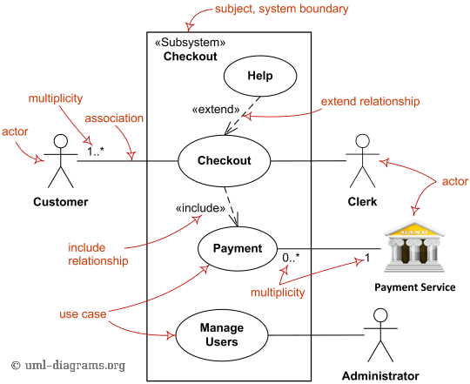

Q2: Relate Gestalt principle(s) with the given interfaces with an explanation:

